Deploying Applications on Kubernetes — A Step-by-Step Practical Guide

Introduction: Kubernetes has become the de facto standard for container orchestration, offering scalability, fault tolerance, and ease of management for applications. In this step-by-step guide, we will walk you through the process of deploying applications on Kubernetes. Whether you’re a beginner or an experienced developer, this guide will provide you with the necessary instructions to get your applications up and running on Kubernetes.

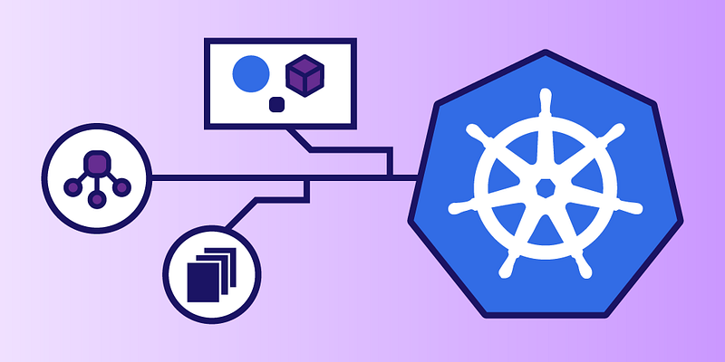

**Prerequisites**

To begin, make sure you have the following prerequisites in place:

1. **A working Kubernetes cluster:** You can set up a cluster using tools like Minikube, Docker Desktop, or a cloud provider such as AWS, Azure, or Google Cloud.
2. **Kubectl:** The Kubernetes command-line tool (kubectl) should be installed and configured to communicate with your cluster.
3. **Docker:** Applications to be deployed on Kubernetes should be containerized using Docker. Ensure that Docker is installed and running on your local machine.

**Step 1: Create a Kubernetes Deployment**

1. **Write a Dockerfile:** Create a Dockerfile for your application, specifying the necessary dependencies and instructions for building the container image.
2. **Build the Docker image:** Use the Dockerfile to build the container image for your application. Run the following command in the terminal:

*docker build -t your-image-name:tag .*

3. **Push the image to a registry:** If you’re using a private registry, push the image to the registry using the following command:

*docker push your-registry/your-image-name:tag*

4. **Define a Deployment manifest:** Create a deployment YAML file (e.g., deployment.yaml) to describe the desired state of your application. Specify the image name, replica count, ports, and any other required configuration.

5. **Apply the Deployment:** Apply the deployment manifest using kubectl:

kubectl apply -f deployment.yaml

6. **Verify the Deployment:** Check the status of the deployment using the following command:

*kubectl get deployments*

**Step 2: Expose the Application**

1. **Create a Service manifest:** To expose your application, create a service YAML file (e.g., service.yaml) that defines the networking rules for accessing the application.
2. **Specify the service type:** Choose the appropriate service type based on your requirements. This could be NodePort, LoadBalancer, or ClusterIP.
3. **Apply the Service:** Apply the service manifest using kubectl:

*kubectl apply -f service.yaml*

4. **Verify the Service:** Check the status of the service using the following command:

kubectl get services

**Step 3: Access the Application**

1. Access the application locally: If you’re using a NodePort service, find the port assigned to the service using kubectl get services. Access the application in your browser using the cluster IP and the assigned port.
2. Access the application externally: If you’re using a LoadBalancer service, wait for the external IP to be assigned. Retrieve the external IP using kubectl get services and access the application using the IP.

**Conclusion:** Congratulations! You have successfully deployed your application on Kubernetes. By following this step-by-step guide, you learned how to create a Kubernetes deployment, expose your application through a service, and access it both locally and externally. Kubernetes offers a powerful platform for deploying and managing containerized applications at scale, and mastering its deployment process is essential for modern application development.

**Note:** Remember to clean up any resources created during this guide to avoid unnecessary costs or resource consumption. You can delete the deployment and service using kubectl delete with the appropriate YAML files.